**1.Create a Spring Web Project using Maven** 

**pom.xml:**

<?xml version="1.0" encoding="UTF-8"?>

<project xmlns="http://maven.apache.org/POM/4.0.0" xmlns:xsi="http://www.w3.org/2001/XMLSchema-instance"

xsi:schemaLocation="http://maven.apache.org/POM/4.0.0 https://maven.apache.org/xsd/maven-4.0.0.xsd">

<modelVersion>4.0.0</modelVersion>

<parent>

<groupId>org.springframework.boot</groupId>

<artifactId>spring-boot-starter-parent</artifactId>

<version>3.5.3</version>

<relativePath/> <!-- lookup parent from repository -->

</parent>

<groupId>com.cognizant</groupId>

<artifactId>spring-learn</artifactId>

<version>0.0.1-SNAPSHOT</version>

<name>spring-learn</name>

<description>Demo project for Spring Boot</description>

<url/>

<licenses>

<license/>

</licenses>

<developers>

<developer/>

</developers>

<scm>

<connection/>

<developerConnection/>

<tag/>

<url/>

</scm>

<properties>

<java.version>17</java.version>

</properties>

<dependencies>

<dependency>

<groupId>org.springframework.boot</groupId>

<artifactId>spring-boot-starter</artifactId>

</dependency>

<dependency>

<groupId>org.springframework.boot</groupId>

<artifactId>spring-boot-starter-test</artifactId>

<scope>test</scope>

</dependency>

<dependency>

<groupId>org.springframework</groupId>

<artifactId>spring-context</artifactId>

</dependency>

</dependencies>

<build>

<plugins>

<plugin>

<groupId>org.springframework.boot</groupId>

<artifactId>spring-boot-maven-plugin</artifactId>

</plugin>

</plugins>

</build>

</project>

application.properties:

spring.application.name=spring-learn

# Logging settings

logging.level.root=info

logging.level.com.cognizant.spring_learn=debug

logging.pattern.console=%d{yyMMdd}|%d{HH:mm:ss.SSS}|%-20.20thread|%5p|%-25.25logger{25}|%25M|%m%n

SpringLearnApplication.java:

package com.cognizant.spring_learn;

import org.slf4j.Logger;

import org.slf4j.LoggerFactory;

import org.springframework.boot.SpringApplication;

import org.springframework.boot.autoconfigure.SpringBootApplication;

@SpringBootApplication

public class SpringLearnApplication {

private static final Logger *LOGGER* = LoggerFactory.*getLogger*(SpringLearnApplication.class);

public static void main(String[] args) {

*LOGGER*.info("START - main()");

SpringApplication.*run*(SpringLearnApplication.class, args);

*LOGGER*.info("END - main()");

}

}

**OUTPUT:**

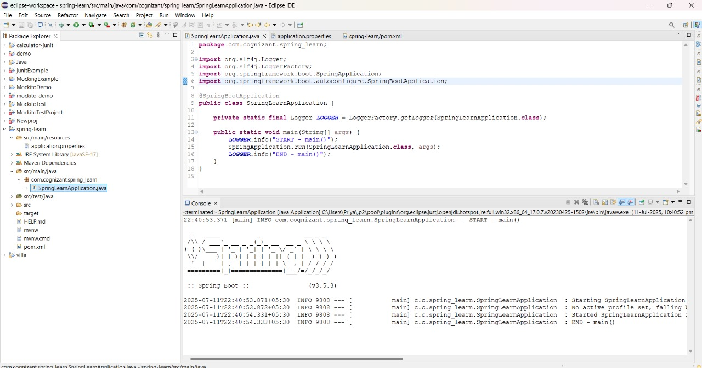

**2. Spring Core – Load SimpleDateFormat from Spring Configuration XML**

SimpleDateFormat with the pattern ‘dd/MM/yyyy’ is created in multiple places of an application. To avoid creation of SimpleDateFormat in multiple places, define a bean in Spring XML Configuration file and retrieve the date.

**pom.xml:**

<dependency>

<groupId>org.springframework</groupId>

<artifactId>spring-context</artifactId>

<version>5.3.33</version>

</dependency>

date-format.xml:

<?xml version="1.0" encoding="UTF-8"?>

<beans xmlns="http://www.springframework.org/schema/beans"

xmlns:xsi="http://www.w3.org/2001/XMLSchema-instance"

xsi:schemaLocation="http://www.springframework.org/schema/beans

https://www.springframework.org/schema/beans/spring-beans.xsd">

<bean id="dateFormat" class="java.text.SimpleDateFormat">

<constructor-arg value="dd/MM/yyyy" />

</bean>

</beans>

**SpringLearnApplication.java:**

package com.example.springlearn;

import java.text.SimpleDateFormat;

import java.util.Date;

import org.springframework.context.ApplicationContext;

import org.springframework.context.support.ClassPathXmlApplicationContext;

public class SpringLearnApplication {

public static void displayDate() throws Exception {

// Load Spring XML Configuration

ApplicationContext context = new ClassPathXmlApplicationContext("date-format.xml");

// Get the dateFormat bean

SimpleDateFormat format = context.getBean("dateFormat", SimpleDateFormat.class);

// Parse date string

Date date = format.parse("31/12/2018");

// Print date

System.out.println("Parsed Date: " + date);

}

public static void main(String[] args) throws Exception {

displayDate();

}

}

**OUTPUT:**

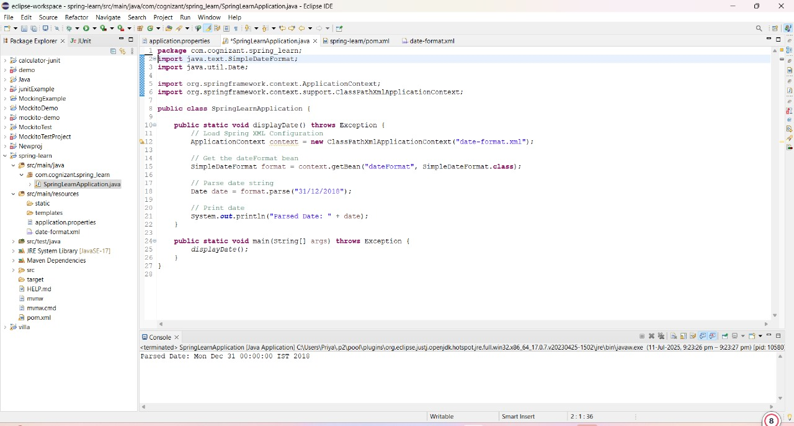  
  
**3. Spring Core - Incorporate Logging**   
  
Incorporate logging in the Spring Boot project created in previous hands on.

**application.properties:**

spring.application.name=spring-learn

logging.level.root=debug

logging.level.com.cognizant.spring_learn=debug

logging.pattern.console=%d{yyMMdd}|%d{HH:mm:ss.SSS}|%-20.20thread|%5p|%-25.25logger**{25}**|%25M|%m%n

**date-format.xml:**

<?xml version="1.0" encoding="UTF-8"?>

<beans xmlns="http://www.springframework.org/schema/beans"

xmlns:xsi="http://www.w3.org/2001/XMLSchema-instance"

xsi:schemaLocation="http://www.springframework.org/schema/beans

https://www.springframework.org/schema/beans/spring-beans.xsd">

<bean id="dateFormat" class="java.text.SimpleDateFormat">

<constructor-arg value="dd/MM/yyyy" />

</bean>

</beans>

**SpringLearnApplication.java:**

**package** com.cognizant.spring_learn;

**import** java.text.SimpleDateFormat;

**import** java.util.Date;

**import** org.slf4j.Logger;

**import** org.slf4j.LoggerFactory;

**import** org.springframework.context.ApplicationContext;

**import** org.springframework.context.support.ClassPathXmlApplicationContext;

**public** **class** SpringLearnApplication {

// Step 1: Create a logger instance

**private** **static** **final** Logger ***LOGGER*** = LoggerFactory.*getLogger*(SpringLearnApplication.**class**);

**public** **static** **void** displayDate() **throws** Exception {

***LOGGER***.info("START");

// Step 2: Load Spring XML Configuration

ApplicationContext context = **new** ClassPathXmlApplicationContext("date-format.xml");

// Step 3: Get the dateFormat bean

SimpleDateFormat format = context.getBean("dateFormat", SimpleDateFormat.**class**);

// Step 4: Parse the date string

Date date = format.parse("31/12/2018");

// Step 5: Log the date instead of printing

***LOGGER***.debug("Parsed Date: {}", date.toString());

***LOGGER***.info("END");

}

**public** **static** **void** main(String[] args) **throws** Exception {

***LOGGER***.info("Application Started");

*displayDate*();

***LOGGER***.info("Application Ended");

}

}

**OUTPUT:**

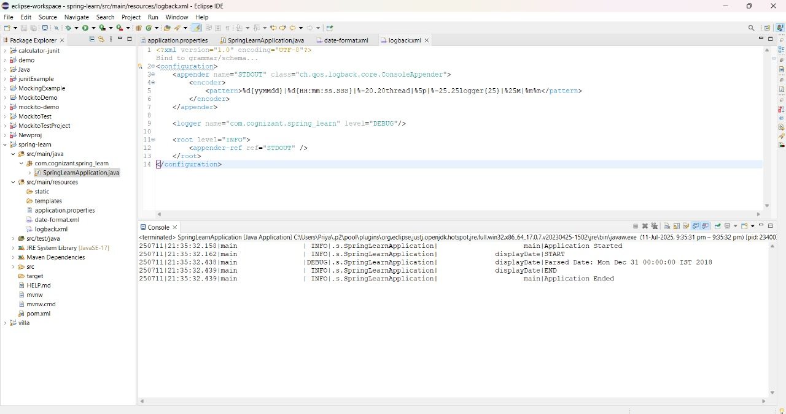

**4. Spring Core – Load Country from Spring Configuration XML**   
  
An airlines website is going to support booking on four countries. There will be a drop down on the home page of this website to select the respective country. It is also important to store the two-character ISO code of each country. 

|  |  |
| --- | --- |
| **Code** | **Name** |
| US | United States |
| DE | Germany |
| IN | India |
| JP | Japan |

Above data has to be stored in spring configuration file. Write a program to read this configuration file and display the details.

**Country.java:**

**package** com.cognizant.spring_learn;

**import** org.slf4j.Logger;

**import** org.slf4j.LoggerFactory;

**public** **class** Country {

**private** **static** **final** Logger ***LOGGER*** = LoggerFactory.*getLogger*(Country.**class**);

**private** String code;

**private** String name;

**public** Country() {

***LOGGER***.debug("Inside Country Constructor.");

}

**public** String getCode() {

***LOGGER***.debug("Getting code: {}", code);

**return** code;

}

**public** **void** setCode(String code) {

***LOGGER***.debug("Setting code: {}", code);

**this**.code = code;

}

**public** String getName() {

***LOGGER***.debug("Getting name: {}", name);

**return** name;

}

**public** **void** setName(String name) {

***LOGGER***.debug("Setting name: {}", name);

**this**.name = name;

}

@Override

**public** String toString() {

**return** "Country [code=" + code + ", name=" + name + "]";

}

}

**country.xml:**

<?xml version="1.0" encoding="UTF-8"?>

<beans xmlns="http://www.springframework.org/schema/beans"

xmlns:xsi="http://www.w3.org/2001/XMLSchema-instance"

xsi:schemaLocation="

http://www.springframework.org/schema/beans

http://www.springframework.org/schema/beans/spring-beans.xsd">

<bean id="country" class="com.cognizant.spring_learn.Country">

<property name="code" value="IN"/>

<property name="name" value="India"/>

</bean>

</beans>

**application.properties:**

spring.application.name=spring-learn

logging.level.org.springframework=info

logging.level.com.cognizant.springlearn=debug

logging.pattern.console=%d{yyMMdd}|%d{HH:mm:ss.SSS}|%-20.20thread|%5p|%-25.25logger**{25}**|%25M|%m%n

**StringLearnApplication.java:**

package com.cognizant.spring_learn;

import org.slf4j.Logger;

import org.slf4j.LoggerFactory;

import org.springframework.context.ApplicationContext;

import org.springframework.context.support.ClassPathXmlApplicationContext;

public class SpringLearnApplication {

private static final Logger LOGGER = LoggerFactory.getLogger(SpringLearnApplication.class);

public static void main(String[] args) throws Exception {

displayCountry();

}

public static void displayCountry() {

LOGGER.info("START");

ApplicationContext context = new ClassPathXmlApplicationContext("country.xml");

Country country = context.getBean("country", Country.class);

LOGGER.debug("Country: {}", country);

LOGGER.info("END");

}

}

**5. Spring Core – Demonstration of Singleton Scope and Prototype Scope**   
  
The Country bean done in the previous hands on will be used to demonstrate the scopes in Spring.

**Country.java:**

package com.cognizant.spring_learn;

import org.slf4j.Logger;

import org.slf4j.LoggerFactory;

public class Country {

private static final Logger LOGGER = LoggerFactory.getLogger(Country.class);

private String code;

private String name;

public Country() {

LOGGER.debug("Inside Country Constructor.");

}

public String getCode() {

LOGGER.debug("Getting code: {}", code);

return code;

}

public void setCode(String code) {

LOGGER.debug("Setting code: {}", code);

this.code = code;

}

public String getName() {

LOGGER.debug("Getting name: {}", name);

return name;

}

public void setName(String name) {

LOGGER.debug("Setting name: {}", name);

this.name = name;

}

@Override

public String toString() {

return "Country [code=" + code + ", name=" + name + "]";

}

}

**country.xml:**

<?xml version="1.0" encoding="UTF-8"?>

<beans xmlns="http://www.springframework.org/schema/beans"

xmlns:xsi="http://www.w3.org/2001/XMLSchema-instance"

xsi:schemaLocation="http://www.springframework.org/schema/beans

http://www.springframework.org/schema/beans/spring-beans.xsd">

<bean id="country" class="com.cognizant.spring_learn.Country">

<property name="code" value="IN"/>

<property name="name" value="India"/>

</bean>

</beans>

**SpringLearnApplication.java:**

package com.cognizant.spring_learn;

import org.slf4j.Logger;

import org.slf4j.LoggerFactory;

import org.springframework.context.ApplicationContext;

import org.springframework.context.support.ClassPathXmlApplicationContext;

public class SpringLearnApplication {

private static final Logger LOGGER = LoggerFactory.getLogger(SpringLearnApplication.class);

public static void main(String[] args) {

displayCountry();

}

public static void displayCountry() {

LOGGER.info("START");

ApplicationContext context = new ClassPathXmlApplicationContext("country.xml");

Country country = context.getBean("country", Country.class);

Country anotherCountry = context.getBean("country", Country.class);

LOGGER.debug("Country: {}", country);

LOGGER.debug("Another Country: {}", anotherCountry);

LOGGER.debug("Same object? {}", country == anotherCountry); // true for singleton

LOGGER.info("END");

}

}

**OUTPUT:**

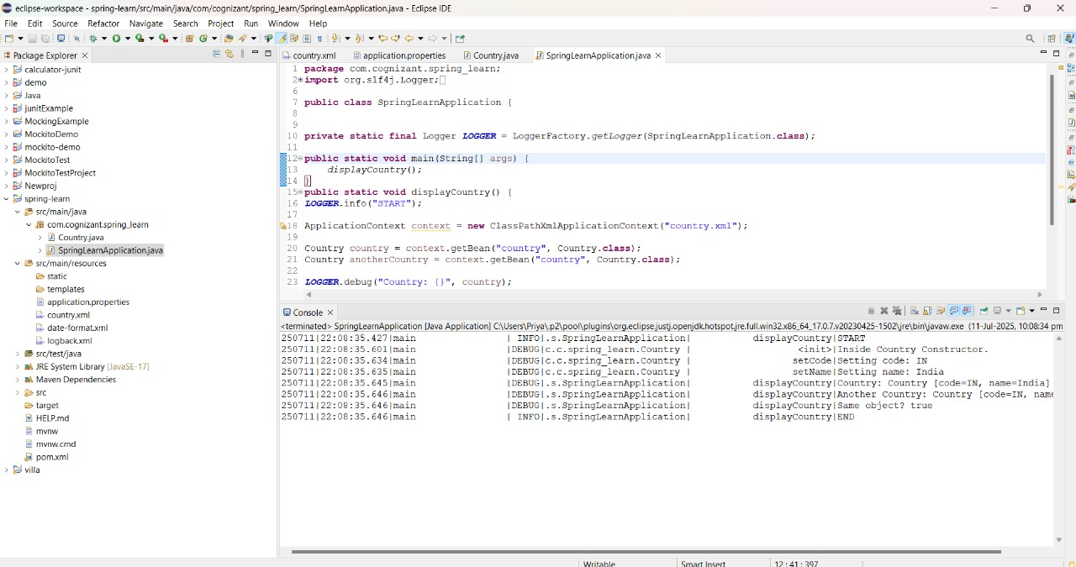

**6. Spring Core – Load list of countries from Spring Configuration XML**   
  
Our main objective was to retrieve the list of four countries for the airlines website. Refer steps below to get this incorporated. 

* Create a separate bean for each of the four country in country.xml.

Create an ArrayList of Country in country.xml.

**country.xml:**

<?xml version="1.0" encoding="UTF-8"?>

<beans xmlns="http://www.springframework.org/schema/beans"

xmlns:xsi="http://www.w3.org/2001/XMLSchema-instance"

xsi:schemaLocation="http://www.springframework.org/schema/beans

https://www.springframework.org/schema/beans/spring-beans.xsd">

<bean id="in" class="com.cognizant.spring_learn.Country">

<property name="code" value="IN"/>

<property name="name" value="India"/>

</bean>

<bean id="us" class="com.cognizant.spring_learn.Country">

<property name="code" value="US"/>

<property name="name" value="United States"/>

</bean>

<bean id="de" class="com.cognizant.spring_learn.Country">

<property name="code" value="DE"/>

<property name="name" value="Germany"/>

</bean>

<bean id="jp" class="com.cognizant.spring_learn.Country">

<property name="code" value="JP"/>

<property name="name" value="Japan"/>

</bean>

<bean id="countryList" class="java.util.ArrayList">

<constructor-arg>

<list>

<ref bean="in"/>

<ref bean="us"/>

<ref bean="de"/>

<ref bean="jp"/>

</list>

</constructor-arg>

</bean>

</beans>

**SpringLearnApplication.java**

**package** com.cognizant.spring_learn;

**import** java.util.List;

**import** org.slf4j.Logger;

**import** org.slf4j.LoggerFactory;

**import** org.springframework.context.ApplicationContext;

**import** org.springframework.context.support.ClassPathXmlApplicationContext;

**public** **class** SpringLearnApplication {

**private** **static** **final** Logger ***LOGGER*** = LoggerFactory.*getLogger*(SpringLearnApplication.**class**);

**public** **static** **void** main(String[] args) **throws** Exception {

*displayCountries*();

}

**public** **static** **void** displayCountries() {

***LOGGER***.info("START");

ApplicationContext context = **new** ClassPathXmlApplicationContext("country.xml");

List<Country> countryList = context.getBean("countryList", List.**class**);

***LOGGER***.debug("Country List: {}", countryList);

***LOGGER***.info("END");

}

}

**OUTPUT:**

